Infosys Springboard Virtual Internship 6.0 Completion Reprot

Batch Number: 13
Start date: 13 FEB 2026
Name: Vaishnavi. C. S
Internship Duration: 40 days

Project Titel
ElectViz Election Data Visualization for Media

Project Objectives
The primary objective of this project is to analyze the data collected from elections in an effective manner using modern data visualization tools. The project mainly deals with the study of voting patterns, performance of political parties, and voter turnout in different regions. It is easy to understand significant data using data visualization tools in an interactive format, such as party-wise performance, voting patterns in different regions, and overall voter turnout in different regions. The system can be used to compare the performance of different political parties and understand how their performance changes in different regions and constituencies. In addition to this, the project aims to develop an interactive and user-friendly reporting system using data visualization tools to help users explore the data in an easy and interactive manner.

Project description in detail
The **Election Data Analysis project** involves the analysis and visualization of the election data to understand the voting patterns, party results, and voter turnout in different regions. The dataset used in this project can be obtained from various online platforms like Kaggle. After obtaining the dataset, preprocessing techniques are used to clean the data. In the preprocessing step, the dataset is cleaned to remove missing values, duplicate rows, and unwanted columns to ensure the accuracy of the data. After preprocessing the data, it is then made suitable for analysis using data modeling techniques. **Power BI** is used to create interactive reports. Various types of visualization tools like KPI cards, bar charts, pie charts, and geographical maps are used to present the key results like the total votes, votes received by each party, results in different constituencies, and voter turnout. In this project, the historical trends of elections, party results, and voter turnout based on different demographic groups are also analyzed. Overall, the system provides an interactive reporting tool that helps users to easily analyze the election results and voting patterns.

Key Measures Used in the Project
There are several measures used in the project to measure performance in the elections and voter turnout.
Total Votes Polled
Total Votes Polled = Σ Votes Cast
This measure is used to calculate the total number of votes cast in different constituencies.
Total Registered Voters
Total Registered Voters = Σ Registered Electors
This measure shows the total number of registered voters who were eligible to vote in the elections.
Voter Turnout Percentage
Voter Turnout (%) = (Total Votes Polled / Total Registered Voters) × 100
This measure shows the total number of voters who turned up to vote in the elections.
Seats Won by Party
Seats Won by Party = Count of Constituencies Won by Each Party
This measure shows the number of seats won by different political parties in the elections.
Vote Share Percentage
Vote Share (%) = (Votes Received by Party / Total Votes Polled) × 100
This measure shows the total number of votes received by different political parties compared to the total number of votes cast in the elections.

Workflow of Election Data Analysis System
Step | Process / Module | Description
Step 1 | Data Integration and Modelin | In this step, the election dataset is collected from sources such as Kaggle. Multiple datasets are integrated and imported into the analysis environment. Data modeling is applied to organize the dataset into a structured format that supports analysis and visualization.
Step 2 | Data Cleaning and Preparation | The collected data is cleaned using data preprocessing techniques. Missing values, duplicate records, and unnecessary columns are removed. The dataset is then structured properly so it can be used to create KPI cards, dashboards, and charts.
Step 3 | Historical Trends Analysis | Past election data is analyzed to understand voting behavior and trends across different years. This includes studying election results, vote share distribution of parties, and comparison of opponent parties in multiple elections.
Step 4 | Dashboard Development | Interactive dashboards are created to visualize election trends and party performance. Charts, KPI cards, and graphical reports are designed to display important insights clearly.
Step 5 | Turnout and Demographic Analysis | Voter turnout and demographic participation are analyzed to understand voting patterns across states and regions.
Step 6 | Party and Candidate Insights | Party performance trends and candidate results are analyzed to provide an overall election summary and support data-driven political analysis.

Key Milestones
Milestone | Description
Data Integration and Modeling | Collecting data from different sources, like Kaggle, integrating different data sets, cleaning the data, and arranging it in a structured format.
Historical Trends Analysis | Analyzing historical data to understand trends in voting, the performance of different political parties in different elections, and changes in votes over the years.
Real-Time Results Visualization | Developing dashboards that can show the results of the election in real time, which can be used to understand the distribution of seats and votes.
Turnout and Demographic Analysis | Analyzing voter turnout in different states, regions, and demographics like gender, age group, and geography type, which includes rural and urban areas.
Party and Candidate Insights | Analyzing the performance of different political parties and their candidates by comparing votes, constituency-wise results, and overall election results.

Project Execution Details
The execution of this project was carried out in a systematic and step-by-step manner using Power BI to analyze India General Election data. The project began with data collection from election-related datasets containing information such as states, constituencies, parties, candidates, total votes, electors, turnout percentage, gender-wise voters, social categories, and election year details. Since the raw data was available in different formats and structures, the first step was to import the data into Power BI and verify its completeness and consistency.
After importing the dataset, the next stage was data preprocessing and cleaning. In this step, unnecessary columns were removed, missing values were checked, duplicate records were eliminated, and inconsistent naming in states, parties, and categories was standardized. Data types were also corrected to ensure that numeric, text, and date fields were properly assigned. This step was very important because clean data is essential for creating reliable visualizations and measures.
Once the data was cleaned, the project moved to data transformation and modeling. Power Query was used to reshape the data and prepare it for analysis. Multiple related tables were created and connected through relationships based on common fields such as state, constituency, party, and year. A proper data model was then designed to support interactive filtering and cross-analysis across all dashboard pages. This relational model improved both accuracy and performance of the report.
The next stage involved creating DAX measures for key calculations. Measures were developed for total votes, total seats, turnout percentage, average winning margin, vote share, alliance-wise seat count, party-wise votes, and demographic-based calculations. These measures formed the analytical core of the dashboard and enabled dynamic reporting based on slicers and user selections. Special attention was given to ensuring that the measures worked correctly across multiple visuals and filters.
After the measures were created, dashboard development was started. Different report pages were designed to represent specific aspects of election analysis. One page focused on the general election overview, another on turnout and demographic analysis, another on party and candidate analysis, and another on historical comparison between election years. Appropriate visuals such as KPI cards, bar charts, donut charts, scatter plots, tables, and map visuals were used to present the insights clearly. Slicers were added for state, party, and year to make the dashboard interactive and user friendly.
The next part of execution involved testing and validation. Each visual was checked against the source data to confirm that the results were accurate. Filters and slicers were tested to ensure that all pages responded properly. Relationships and DAX measures were also verified so that no incorrect aggregations or duplicate counts appeared in the report. This testing phase helped in improving the accuracy and dependability of the final dashboard.
Finally, the dashboard was refined by improving layout, formatting, alignment, titles, and visual consistency. Colors, borders, icons, and labels were adjusted to make the report more professional and readable. Performance optimization was also considered by reducing unnecessary calculations and keeping the data model organized. After completing all these steps, the final dashboard was ready and provided a complete analysis of election results, turnout, demographic distribution, party performance, and historical trends in a single interactive Power BI solution.
For this project, the execution process not only improved technical skills in Power BI, Power Query, and DAX, but also provided practical experience in handling real-world data analysis problems from data collection to final visualization.

Snapshots / Screenshots
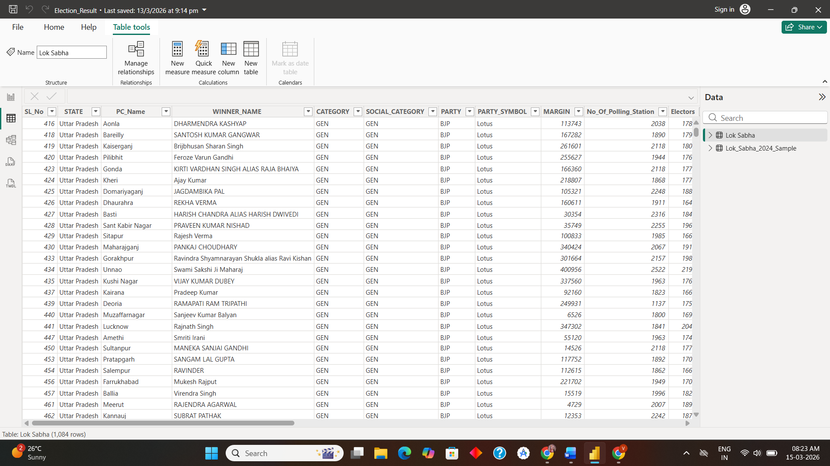
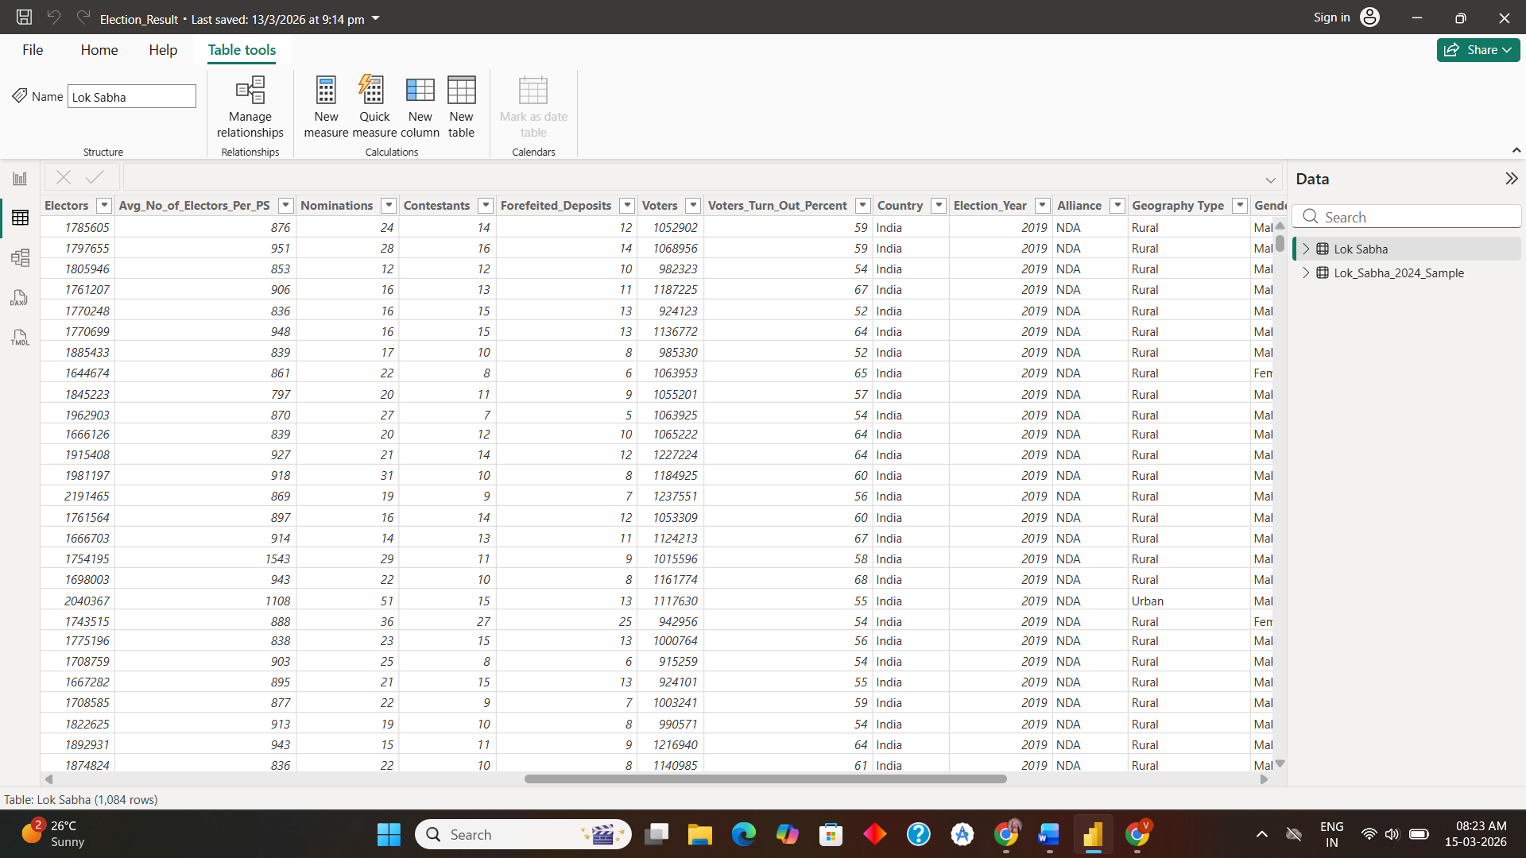
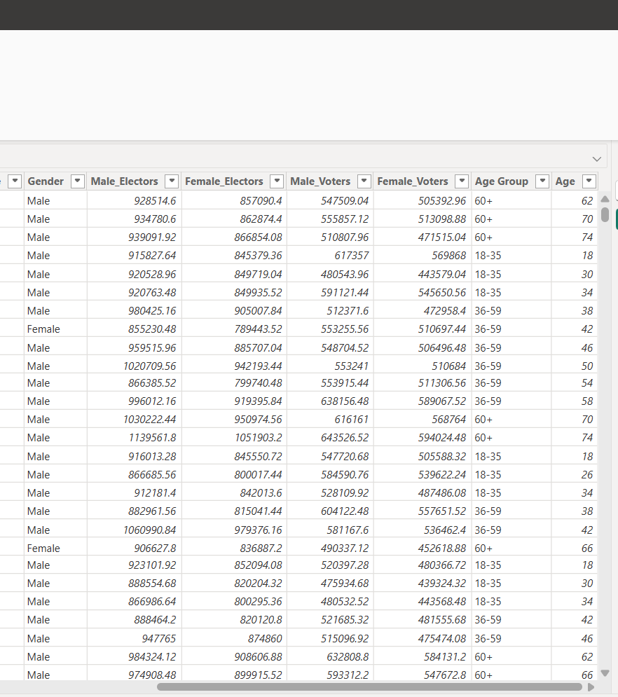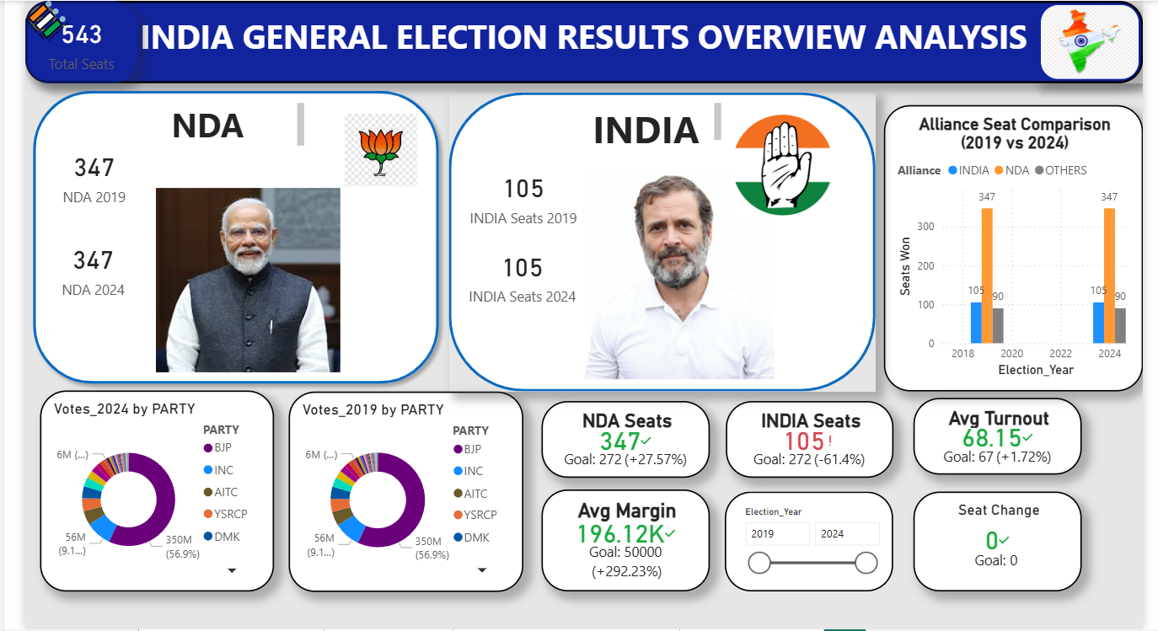

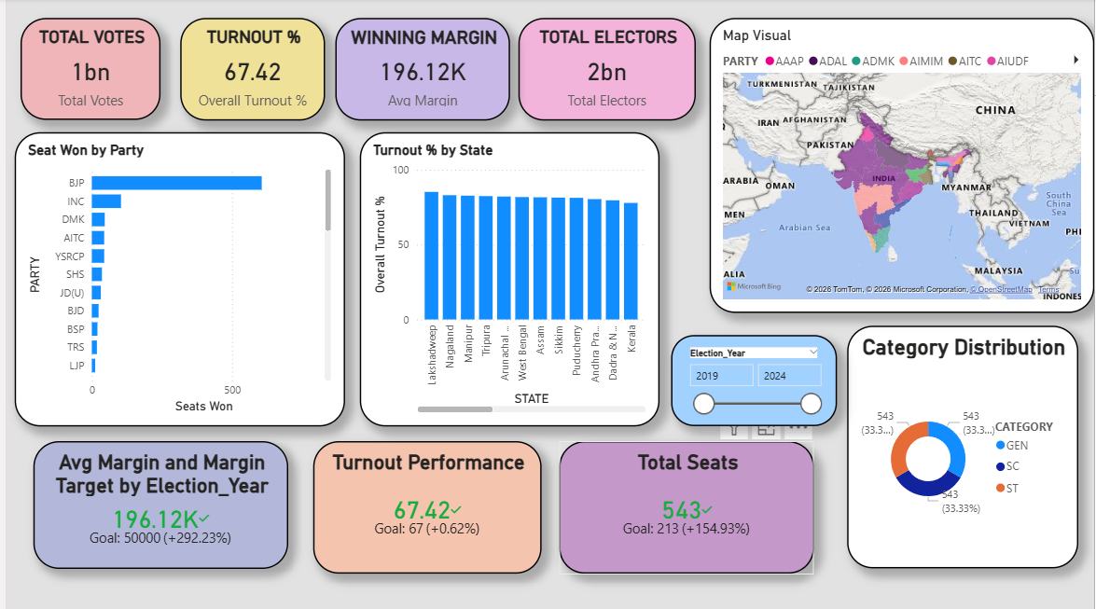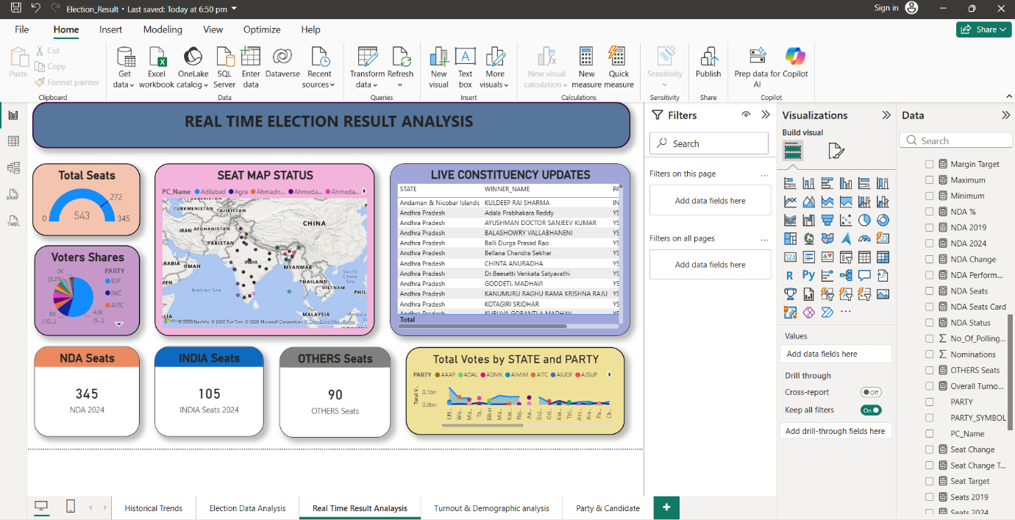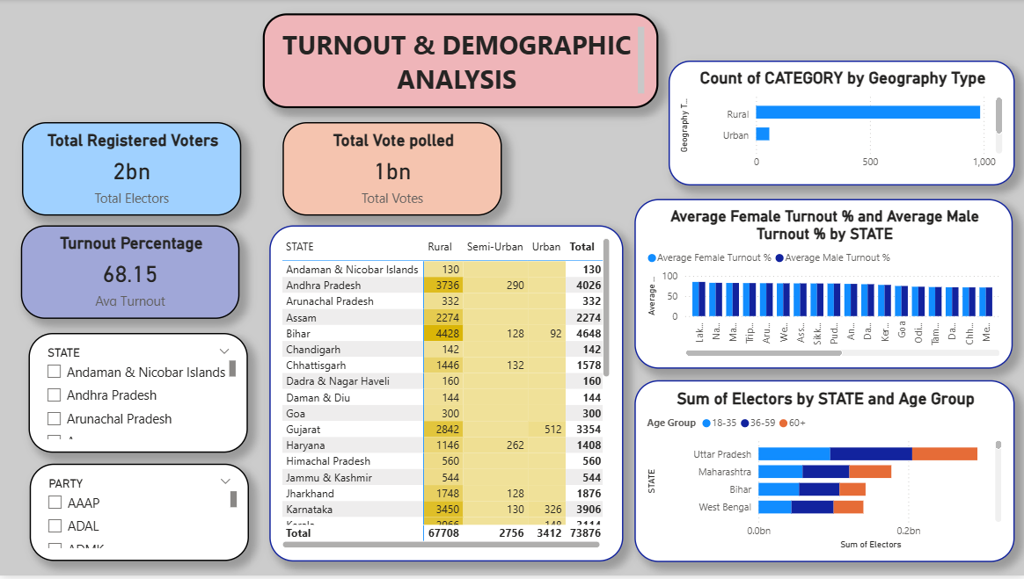
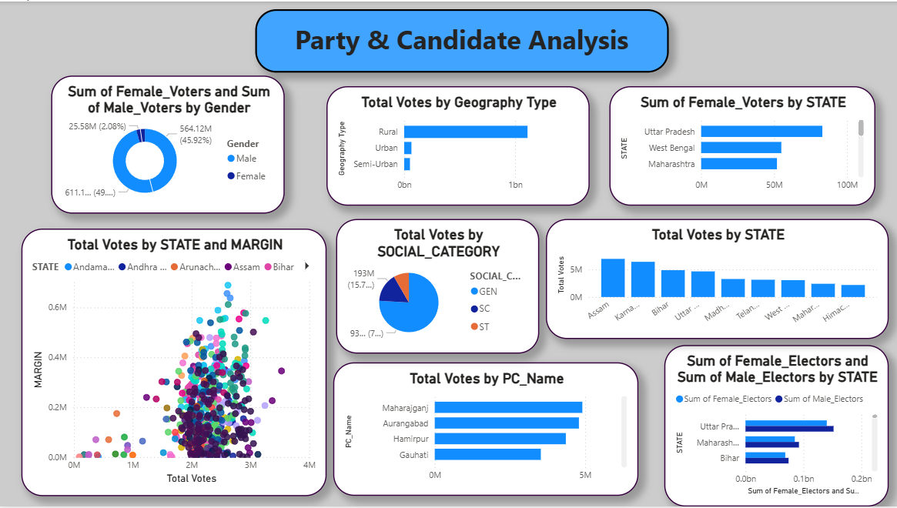

Challenges Faced
There were several challenges faced while developing the Election Data Analysis project. The first major challenge was dealing with data inconsistency in the given data set, where there were missing values and different data formats in the data set. The second major challenge was creating complex DAX formulas to calculate important measures such as vote share, turnout percentage, and seats won by different political parties. The third major challenge was designing a user-friendly layout for the dashboard, where the visualization had to present large amounts of data in an easy and clear manner for the user to understand. The fourth major challenge was performance optimization of the Power BI dashboards to ensure fast loading and usage of the dashboard with slicers and filters applied.

Learning Outcomes
Several key skills and ideas have been learned through this project. For example, the project helped in gaining hands-on experience in using Power BI to create interactive dashboards and reports. It also helped in improving knowledge of various techniques used in data modeling, which is critical in arranging the data and establishing relationships between different data tables. Creating measures also helped in improving knowledge of DAX calculation, which can be used in data analysis in Power BI. In addition, the project helped in improving knowledge of various techniques used in designing interactive dashboards, including the use of various visualization tools and arranging layout elements appropriately.

Testimonials from Team
**Election Data Analysis Project** was a learning experience for the entire team. All team members were involved in different phases of the project, such as data collection, data cleaning, creating dashboards, and data analysis. The team was able to learn how to work in collaboration with one another and develop problem-solving abilities by working together in one project. The team was able to learn how to work in collaboration with one another and develop problem-solving abilities by working together in one project. The team was able to learn how to utilize **Power BI for data visualization**, learn how to work with real-world data, and learn data modeling techniques. The team was able to learn how to utilize **Power BI for data visualization**, learn how to work with real-world data, and learn data modeling techniques. The team was able to learn how to utilize **Power BI for data visualization**, learn how to work with real-world data, and learn data modeling techniques. The team was able to learn how to utilize **Power BI for data visualization**, learn how to work with real-world data, and learn data modeling techniques. The team was able to learn how to utilize **.

Future Enhancements
- Integration of real-time election data for live updates and accurate insights
- Implementation of machine learning models to predict election outcomes and analyze voter behavior
- Inclusion of more detailed demographic data such as education, income, and occupation
- Addition of advanced interactive features like drill-through, filters, and customized views
- Performance optimization to improve dashboard speed and responsiveness
- Development of a web or mobile application interface for better accessibility
- Integration of multiple data sources for comprehensive analysis
- Automation of data updating process to ensure efficiency and scalability

Conclusion
The **Election Data Analysis project** provided valuable experience in analyzing and visualizing large datasets to understand election results and voting behavior. The project focused on collecting election data, cleaning and preprocessing it, and organizing it using data modeling techniques to ensure accurate analysis. Using **Power BI**, interactive dashboards and reports were created to present key insights such as voter turnout, party performance, vote share distribution, and constituency-level results. Various visualization tools like KPI cards, bar charts, pie charts, and geographical maps helped in clearly presenting the information.
Through this internship project, important concepts such as **data preprocessing, data modeling, DAX calculations, and dashboard design** were learned and applied in a practical environment. The project also helped in understanding how data visualization can simplify complex datasets and support better decision-making. Overall, the system provides an effective and interactive platform for exploring election data and identifying voting trends. This internship experience enhanced technical knowledge, analytical thinking, and practical skills in **data analysis and business intelligence tools**.

